IDF Applicant Guide

Thank you for your interest in applying for employment with International Dehydrated Foods, Inc. First you will need to go to our web-site: www.idf.com/careers/ to view our current job openings.

Open job positions are listed as blue hyperlinks on the right side of the screen. Click the hyperlink to view job details. To search for a job, enter the job title or other keyword(s) in the Filter By field. Clink the arrow next to an area for options to narrow your search.

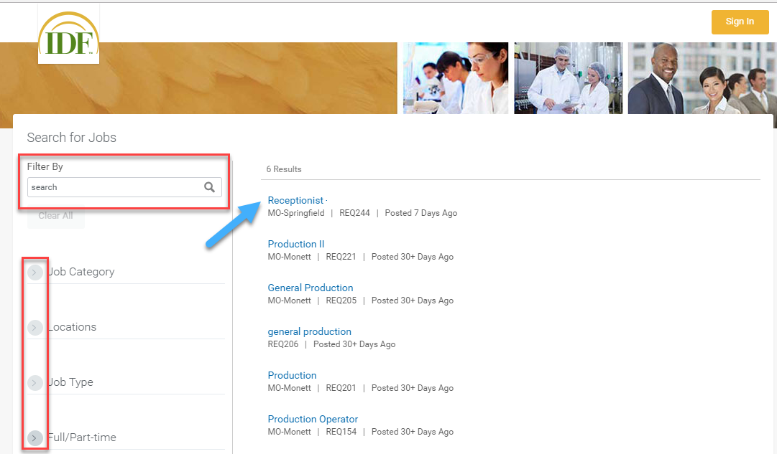

After reviewing the job details and determining you meet the qualifications for the position, you can submit an application by clicking on the Apply button. If you have an updated LinkedIn profile, you can apply through your LinkedIn account by clicking on the Apply with LinkedIn button.

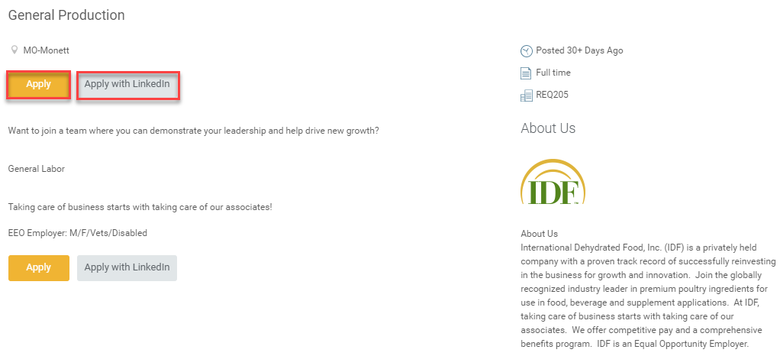

If you already have an account, you can sign in using your email address and password. If this is your first time to apply, you will need to create an account by clicking on the Create Account button.

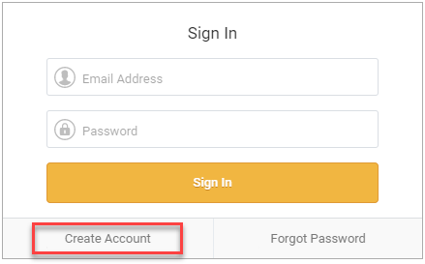
You have the option to drop or upload your resume which will pre-populate the application with your information. Click Next.

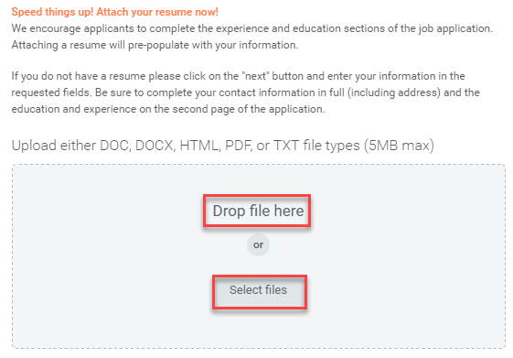
The next screen will ask you to complete your information. A field with a red asterisk is required. Click Next.
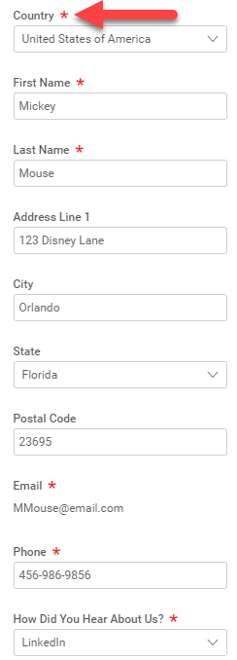
If you added your resume, your Work Experience and Education will be pre-populated but you will need to review for accuracy. If you did not include a resume, you will need to input your Work Experience and Education. Click Next.

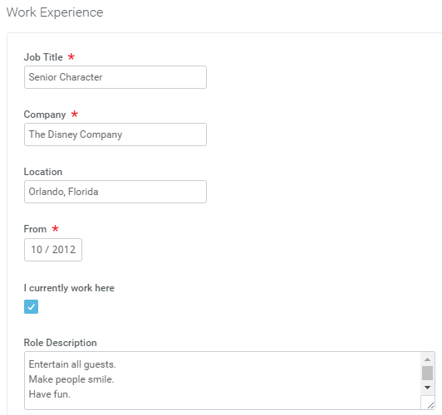

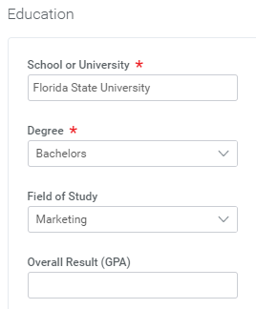

Next, you will answer a series of Application Questions. A question with red asterisks means responses are required. Click Next.

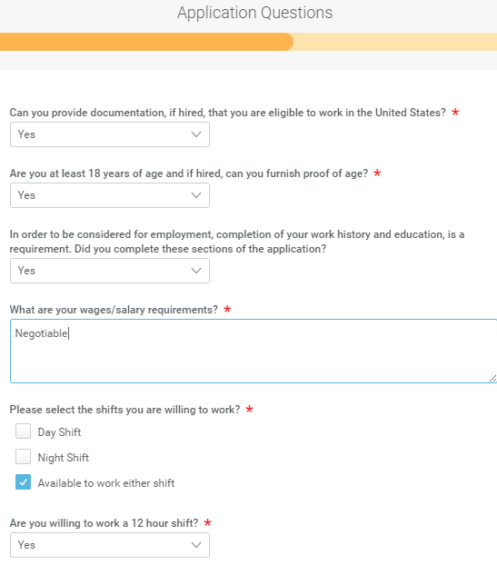

You will be asked to provide Voluntary Disclosures as part of your application.

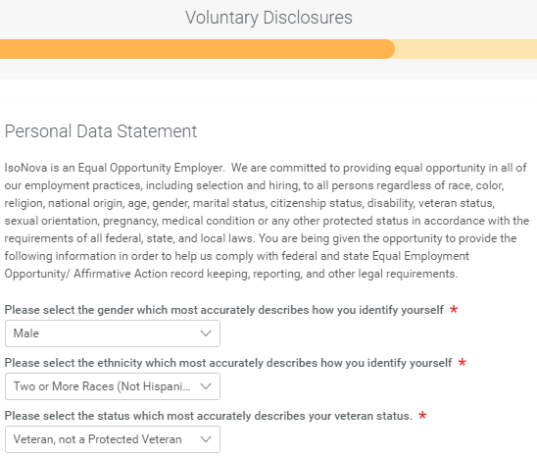
You will need to select your responses and accept the terms of conditions and then click Next.

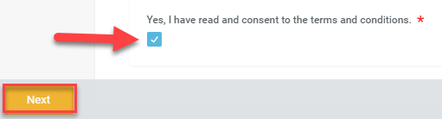

Next you will be asked for a Voluntary Self-Identification of Disability. You will need to provide your response, insert your name and date and click Next.

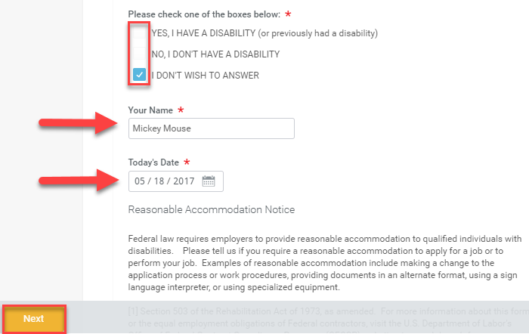

The final step is to Review your application and when you are ready, click Submit.

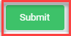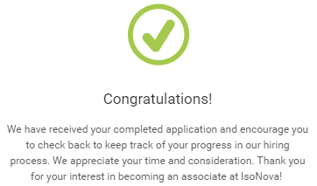

If you are extended an offer of employment, you will receive a verbal offer followed by an email notification with a link to your Workday account so you can review your offer letter and benefits. Once you have signed in, you will need to go to My Applications. You will see an amber marking next to a blue hyperlink with the job title. Click on the job title.

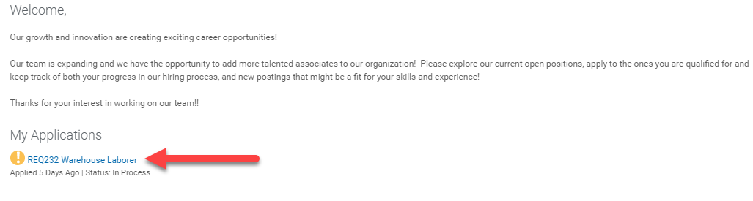
Next, you will need to click on the blue hyperlink that says Review Documents.

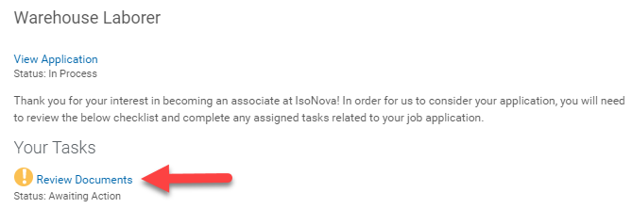

By clicking on the blue hyperlinks, you may review your Offer Letter and Benefits at a Glance details. Once you are ready to accept your offer, check the acknowledgement and click OK.

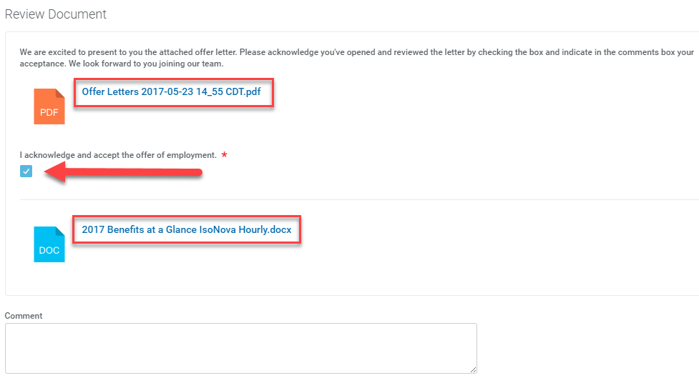
As part of your background check you will receive an email asking you to provide your Social Security Number and Date of Birth. Click on the blue hyperlinks to provide that information. Click OK.

